Chair of Diplomatic Translation
Students' educational club «English club»
English Club was founded at the department of foreign languages in November, 2008. Currently, the head of the club is a senior teacher Ibrayemova E.B.
The purpose of the club:
- Improving the students language skills ;
- The organization of conferences, seminars, round tables, meetings;
- Presentation of the international educational programs for students of Faculty of International Relations;
Events are held at the club in order to improve the students' knowledge. All teachers of the department take an active part in the club’s meetings.
Today, the club is actively working in English, aimed at creating a language practice of the students, English language learners. The club meets regularly to conduct interviews, watching movies in English, discuss them.
Our club organized next round tables on the themes: dedicated to the Independence Day of the Republic of Kazakhstan, on the theme "The five most important events in the history of independent Kazakhstan", "Homage to the elders, respect for the younger", "Problems of youth in Kazakhstan and abroad", "Youth and Science : Student’s opinion on the problems and solutions "," The Family: yesterday, today and tomorrow "," The causes of the collision in Ukraine"," Migration "," Kazakhstan and the WTO ", an evening presentation on the work of E. Hemingway " The Old Man and Sea " according to the project " 100 books ".
Teachers and students of the department with great interest to participate in round tables and discussions of the club «English club» and actively contribute to events at a high level.
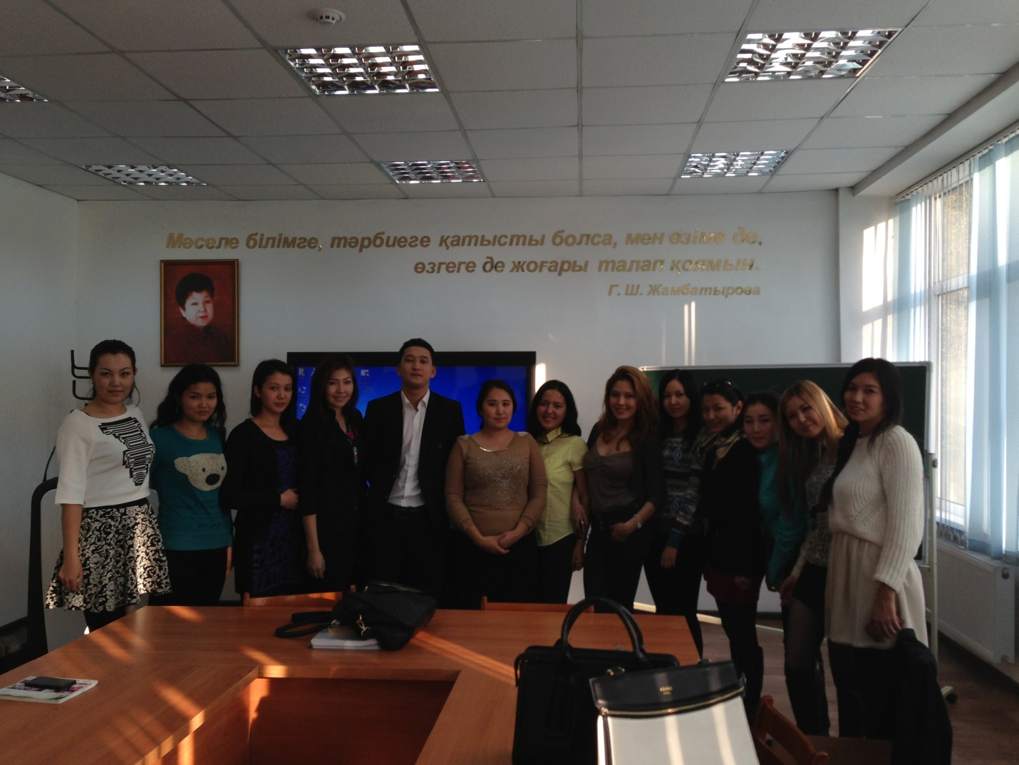
Round table - "Homage to the elders, respect for the younger." 1,2,3 course students of the Faculty of International Relations.

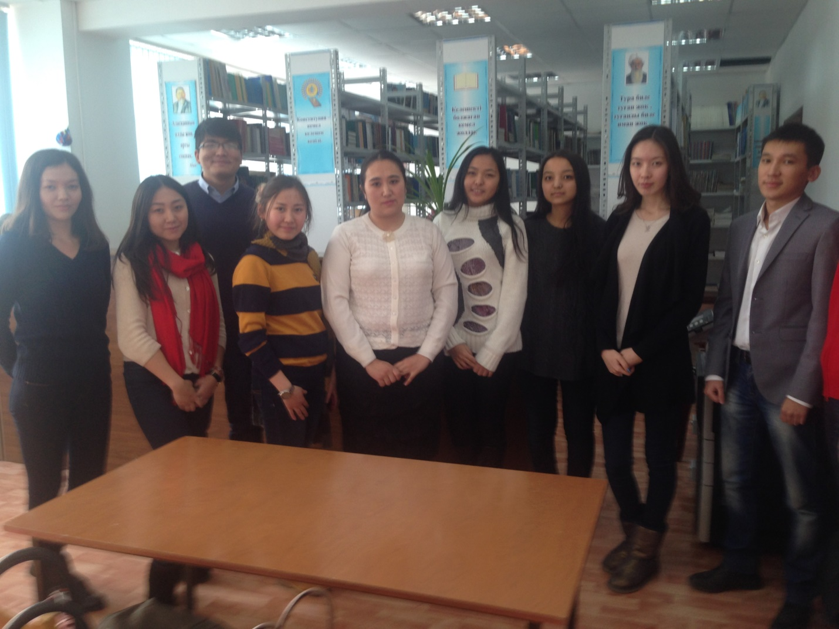
Evening -presentation to E. Hemingway’s book "The Old Man and the Sea" according to the project "100 books"

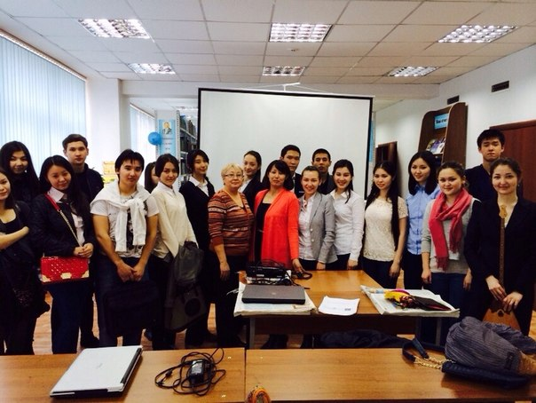
Meeting with PhD doctor of Research Institute and KazNU Zhambylkyzy M. "Youth and Science: students look at problems and solutions" in the reading room of the Faculty.

